Order Of Service

Singing: Psalm 145—CW page 119

Reading: Psalm 113

Opening Hymn: TLH 657

Reading: Hebrews 11:1-7

Request Hymn: CW Supplement 754

Reading: Luke 9:10-17

Sermon Hymn: TLH 656

Sermon Text: Acts 9:32-35

A Certain Man

Prayer

The Apostles’ Creed, TLH page 12

Holy Communion

The Lord's Prayer

The Blessing

Closing Hymn: TLH 577

************

Bible Study: Lambs: Narwhals
Sheep: Deut. 15:1-11
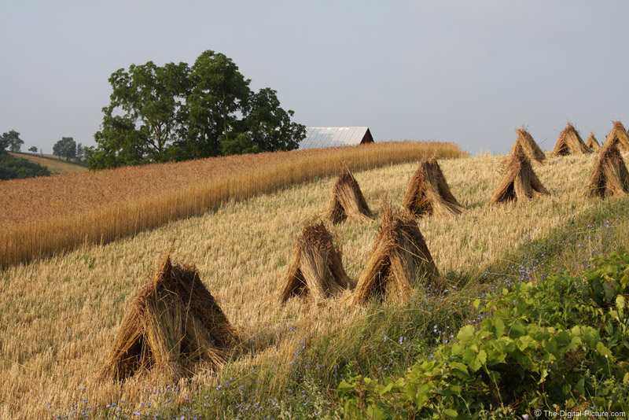

Amish Harvest

Water
Of
Life

10 November 2024

W A T E R O F L I F E

Independent Christian Church—Conservative Lutheran Doctrine

Worship Service: 9:30 a.m.

Larry Cooper, Pastor E-Mail address:
lcooper@wateroflife.cc
Web Site:
www.wateroflife.cc

* * * * * * * * * * * * * * * * * * * * * * * * * * *

Sermon Text: Acts 9:32-35

A Certain Man

* * * * * * * * * * * * * * * * * * * * * * * * * * *

32 And it came to pass, as Peter passed throughout all quarters, he came down also to the saints which dwelt at Lydda.

33 And there he found a certain man named Aeneas, which had kept his bed eight years, and was sick of the palsy.

34 And Peter said unto him, Aeneas, Jesus Christ maketh thee whole: arise, and make thy bed. And he arose immediately.

35 And all that dwelt at Lydda and Saron saw him, and turned to the Lord.

